Waterfall Model in SDLC
Introduction
The Waterfall Model is one of the earliest and most widely used Software Development Life Cycle (SDLC) models. It follows a linear and sequential approach where each phase must be completed before the next one begins. The output of one phase becomes the input for the next. Because of this structure, the model resembles a waterfall—flowing steadily downward through different stages.

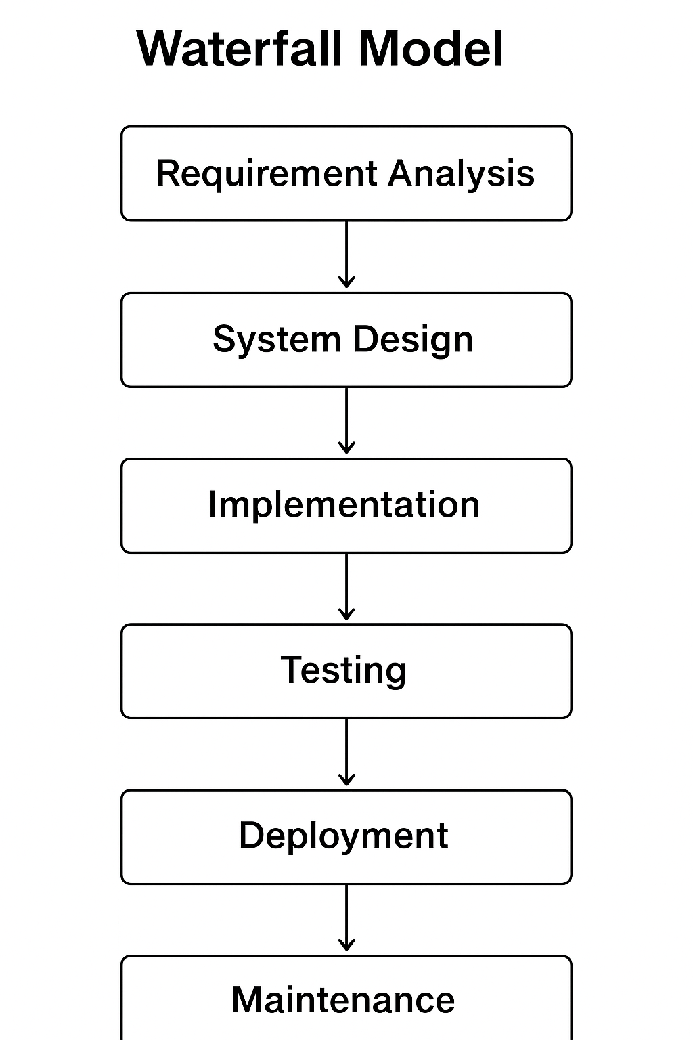
Phases of the Waterfall Model
The Waterfall Model consists of the following phases:
1. Requirement Analysis
In this phase, all system requirements are collected and documented. Stakeholders, users, business analysts, and developers work together to define:
- Functional requirements
- Non-functional requirements
- Constraints
- Expected outputs
2. System Design
Based on the SRS, the design team creates the system’s architecture.
This includes:
- Database design
- User interface design
- System architecture
- Data flow design
- Technology stack selection
The design document acts as a blueprint for developers.
3. Implementation (Development)
In this phase, developers write the actual code.
Each component or module is developed independently following the design guidelines.
Key activities include:
- Writing code
- Code reviews
- Integration of modules
After development, the product is ready for testing.
4. Testing
The software is tested to ensure it is free of errors and meets the requirements.
Types of testing include:
- Unit testing
- Integration testing
- System testing
- Acceptance testing
Any bugs found are fixed before deployment.
5. Deployment
After successful testing, the software is delivered to the customer or deployed in the production environment. It may be released in stages or as a full release depending on the project.
Activities include:
- Installation
- Configuration
- User training (if needed)
6. Maintenance
Once deployed, the software enters the maintenance phase.
Maintenance activities include:
- Bug fixing
- Updates and improvements
- Performance optimization
- Support and monitoring
This phase continues as long as the software remains in use.
Characteristics of the Waterfall Model
- Linear and sequential flow
- Easy to understand and manage
- Documentation-heavy
- Each phase must be completed before moving on
- Best suited for projects where requirements are fixed and clear
Advantages
- Simple to use and understand
- Well-structured and disciplined
- Clear milestones and deliverables
- Easy to manage due to fixed phases
- Works well for small or low-complexity projects
Disadvantages
- Very rigid (not suitable when requirements change)
- No working software is produced until late in the cycle
- Difficult to go back to previous phases
- High risk if initial requirements are incomplete
When to Use the Waterfall Model
The Waterfall Model is most effective when:
- Requirements are well-understood and unlikely to change
- Technology is stable
- The project is small or medium-sized
- Strict documentation is required
- The client prefers a well-defined process

V-Model in SDLC
Introduction
The V-Model, also known as the Verification and Validation Model, is an extension of the Waterfall Model. Instead of moving linearly, the development process is shaped like a V, where each development phase on the left side has a corresponding testing phase on the right side.
The V-Model emphasizes early testing, meaning testing activities are planned in parallel with development activities. This ensures higher quality, better planning, and fewer defects later in the cycle.

Why It Is Called V-Model
It is called the V-Model because the phases of development and testing are arranged in a V-shaped structure:
- Left side of the V → Verification phases (planning + designing)
- Right side of the V → Validation phases (testing)
- Bottom of the V → Implementation/coding
Each stage on the left has a corresponding test stage on the right.
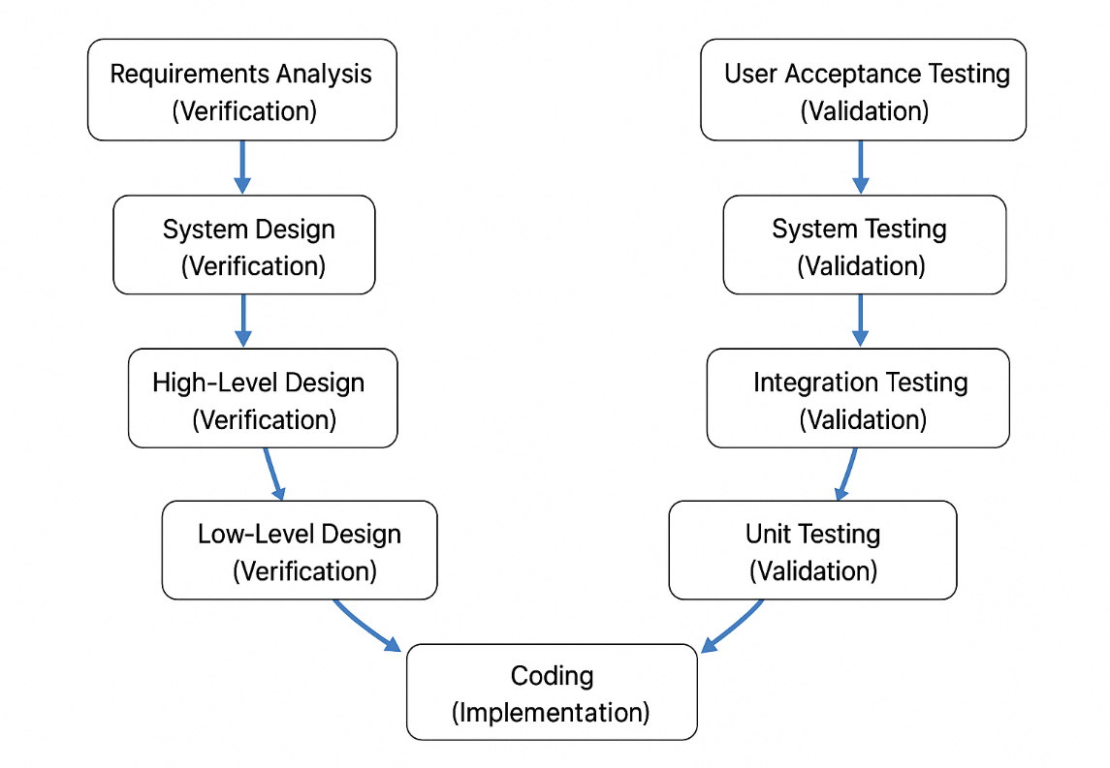

Phases of the V-Model
1. Requirements Analysis (Verification)
In this initial phase, all system requirements are gathered from the customer.
Deliverable: Requirements Specification Document (RSD).
2. System Design (Verification)
Architects design the overall system structure, including hardware/software requirements and system architecture.
Deliverable: System Architecture Design (SAD).
3. High-Level Design (HLD) (Verification)
The system is broken down into major modules. This level defines:
- Module interactions
- Database architecture
- Interfaces
Deliverable: HLD Document.
4. Low-Level Design (LLD) (Verification)
Developers design each module in detail. Focus is on:
- Logic design
- Functions
- Inputs/outputs
- Algorithms
Deliverable: LLD Document.
5. Coding (Implementation)
This is the bottom phase of the V.
All modules are coded and integrated.
This phase produces the Source Code.
Validation Phases
6. Unit Testing
Corresponds to: LLD
Ensures that individual units/modules work correctly.
7. Integration Testing
Corresponds to: HLD
Tests interactions between integrated modules.
8. System Testing
Corresponds to: System design
Ensures the entire system works according to requirements.
9. User Acceptance Testing (UAT)
Corresponds to: Requirement Analysis
Performed by the client/user.
Ensures the final system meets business needs.
Characteristics of the V-Model
- Each development phase has an associated testing phase.
- Testing is planned early, reducing defects.
- Highly structured and disciplined.
- Emphasizes verification + validation.

Advantages
- Early test planning reduces defects.
- Better quality and reliability.
- Clear and easy to understand.
- Works well for small to medium-sized projects.

Disadvantages
- Not flexible—changing requirements is difficult.
- Costly if requirements are unclear.
- Not suitable for complex or iterative projects.

When to Use the V-Model
- Requirements are clear and stable
- High reliability and quality are required
- Projects related to medical devices, banking, aerospace, defense
- Suitable for small to medium complexity systems

Spiral Model in SDLC – Documentation
Introduction
The Spiral Model is an SDLC model that combines the features of both the Waterfall Model and the Iterative Model. It was introduced by Barry Boehm and is mainly used for large, complex, and high-risk projects.
The model is called spiral because the development process moves outward in loops (spirals), where each loop represents a phase of the project. Each loop passes through four major stages:
- Planning
- Risk Analysis
- Engineering (Development & Testing)
- Evaluation (Customer Review)
As the project progresses, the spiral expands—meaning the product increases in size and detail.

Why It Is Called a Spiral?
The model resembles a spiral shape because:
- Development happens in multiple iterations (loops).
- Each loop adds more functionality.
- The project moves outward with each cycle.
Each loop represents a more advanced version of the software.

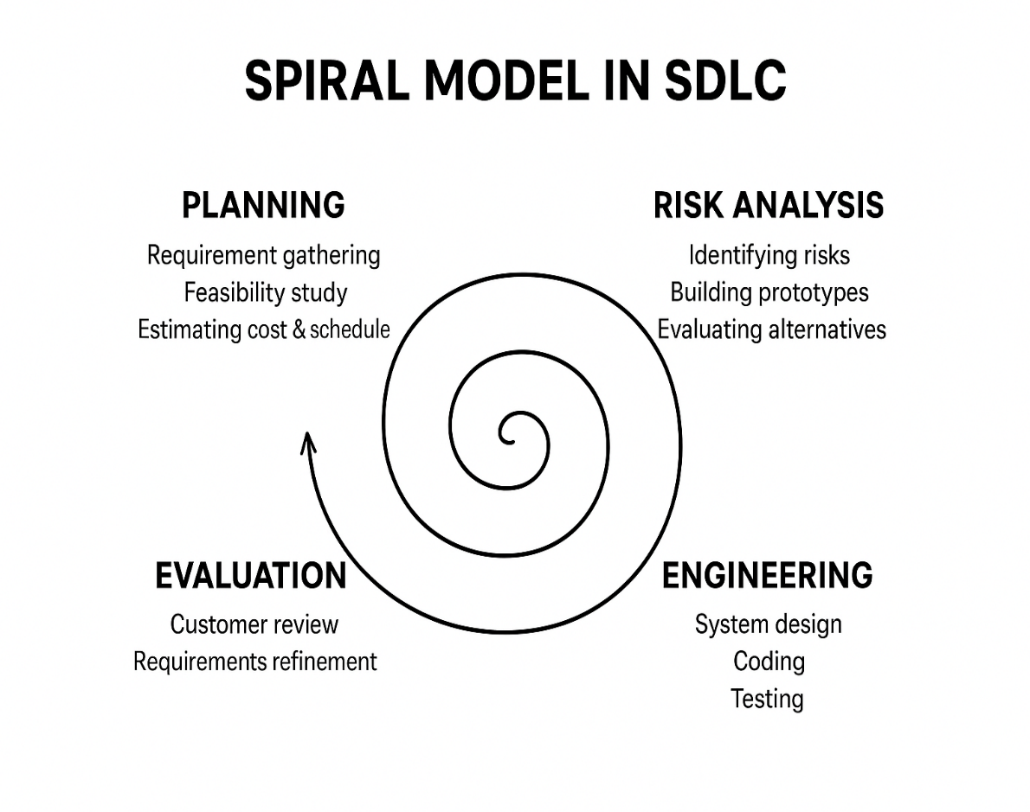
Phases of the Spiral Model
1. Planning Phase
In this phase, the objectives, requirements, constraints, and business needs of the project are identified.
Activities:
- Requirement gathering
- Feasibility study
- Defining possible solutions
- Estimating cost & schedule
This phase ensures the next steps are well-defined.
2. Risk Analysis Phase
This is the core of the Spiral Model.
Risks are identified and strategies are prepared to handle or avoid them.
Activities:
- Identifying technical, financial & operational risks
- Building prototypes to reduce uncertainty
- Alternative solutions
- Evaluation of mitigation strategies
This phase makes the model ideal for highly risky projects.
3. Engineering Phase
This phase includes actual software development tasks.
Activities:
- Designing system architecture
- Coding modules
- Integrating components
- Testing (unit, integration, system)
A working version of the software is produced in each loop.
4. Evaluation Phase
In this phase, the customer reviews the prototype or version developed during the current loop.
Activities:
- Customer feedback
- Requirements refinement
- Approval for next loop
After evaluation, the next spiral cycle begins with updated planning.
Characteristics of the Spiral Model
- Highly risk-driven
- Uses prototyping extensively
- Combines iterative development with systematic steps
- Flexible and adaptable to change
- Suitable for long-term, large, expensive projects
Advantages
- Greatly reduces project risks
- Allows repeated customer feedback
- Supports frequent changes
- Good for large and complex systems
- Early development of prototypes
Disadvantages
- Expensive due to repeated cycles
- Requires strong risk analysis expertise
- Not suitable for small projects
- Hard to manage due to complexity
When to Use the Spiral Model
Use this model when:
- Project is large, complex, and high-risk
- Requirements are unclear or evolving
- Frequent customer feedback is required
- Prototyping is needed
- Long-term project with major updates
Agile Model in SDLC – Documentation
Introduction
The Agile Model is an SDLC approach that focuses on flexibility, collaboration, and rapid delivery. Instead of developing the entire project at once, Agile breaks the project into small, manageable parts called iterations or sprints, usually lasting 2–4 weeks.

Key Principles of Agile
Agile is built on four core values:
- Individuals and interactions over processes and tools
- Working software over comprehensive documentation
- Customer collaboration over contract negotiation
- Responding to change over following a plan
These principles help teams deliver high-quality software in a fast and flexible way.

How Agile Works
Agile development is iterative and incremental:
- The project is divided into small cycles called sprints
- Each sprint includes:
  - Planning
  - Designing
  - Coding
  - Testing
  - Reviewing
- At the end of each sprint, a working software module is delivered
- Customer reviews it and gives feedback
- Team improves or adjusts in the next sprint
This loop continues until the final product is ready.
Agile Model in SDLC
Introduction
The Agile Model is an SDLC approach that focuses on flexibility, collaboration, and rapid delivery. Instead of developing the entire project at once, Agile breaks the project into small, manageable parts called iterations or sprints, usually lasting 2–4 weeks.

Key Principles of Agile (Based on Agile Manifesto)
Agile is built on four core values:
- Individuals and interactions over processes and tools
- Working software over comprehensive documentation
- Customer collaboration over contract negotiation
- Responding to change over following a plan
These principles help teams deliver high-quality software in a fast and flexible way.
How Agile Works
Agile development is iterative and incremental:
- The project is divided into small cycles called sprints
- Each sprint includes:
  - Planning
  - Designing
  - Coding
  - Testing
  - Reviewing
- At the end of each sprint, a working software module is delivered
- Customer reviews it and gives feedback
- Team improves or adjusts in the next sprint
This loop continues until the final product is ready. 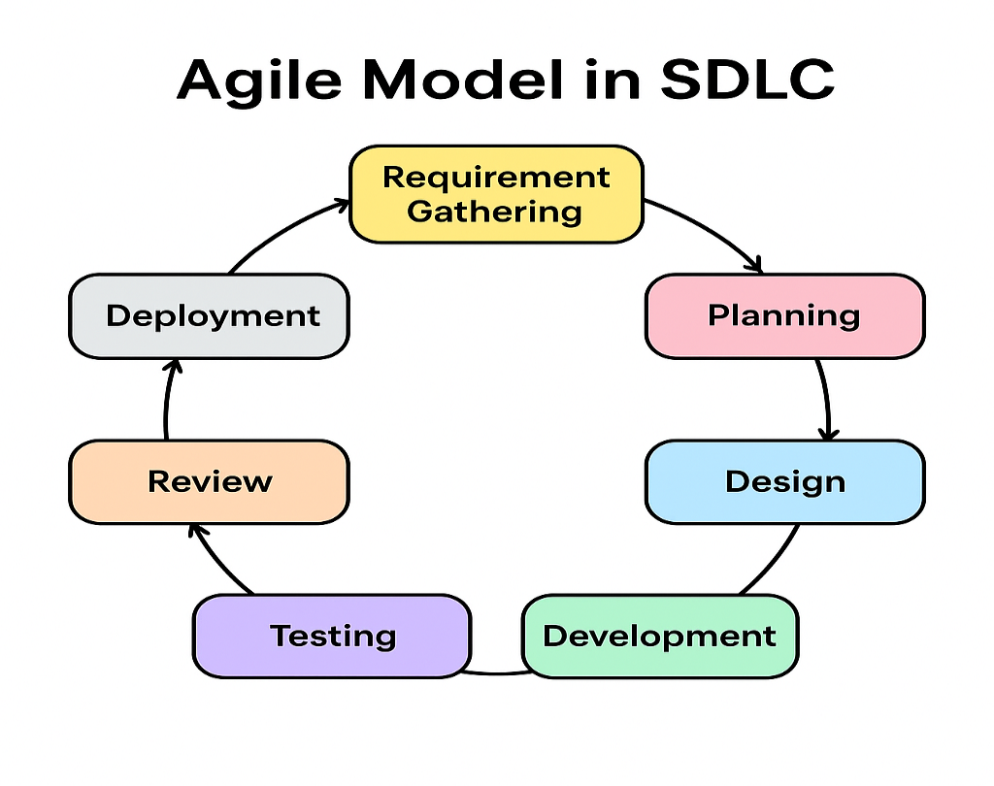
Phases of the Agile Model
1. Requirement Gathering
High-level requirements are collected.
Detailed requirements are taken before each sprint, not all at once.
2. Planning
The team creates a product backlog (list of all features).
For each sprint:
- Features are chosen
- Tasks are assigned
- Sprint duration is fixed
3. Design
UI/UX and system design for selected sprint features is created.
Design evolves throughout the project.
4. Development
Developers build the selected features.
Code is created in short cycles with continuous integration.
5. Testing
Testing is done during each sprint, not at the end.
This includes:
- Unit testing
- Integration testing
- System testing
- User testing
6. Review
After each sprint, the team presents the working product to the customer.
Their feedback shapes the next sprint.
7. Deployment
Product increments are released periodically.
Small releases allow early user benefits.
8. Maintenance
Bugs are fixed and updates are done in next sprints.
Characteristics of Agile
- Highly flexible
- Continuous customer involvement
- Fast delivery of working modules
- Changes are welcomed anytime
- Team collaboration is strong
- Daily stand-up meetings (Scrum)
Advantages
- High customer satisfaction
- Faster delivery
- Adaptable to changes
- Better risk detection
- Continuous improvement
- High-quality product
Disadvantages
- Requires experienced team
- Not suitable for very small or very large teams
- Hard to predict timelines and costs
- Documentation may be less detailed
- Frequent customer involvement needed
When to Use the Agile Model
- Requirements change frequently
- Customer wants regular updates
- Fast delivery is required
- Complex and long-term projects
- Projects needing flexibility (web apps, mobile apps, SaaS, startups)

